Statistics Lecture 7.3: Confidence Interval for the Sample Mean, Population Std Dev -- Known

Estimating Population Mean:

What you need to estimate Population Mean:
- Random sample
- Population Standard Deviation, 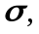 assumed to be known.
- n is sample size
  - 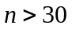
  - 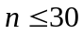 - The population must be normally distributed, Then the sampling distribution of the sample mean will be normally distributed.

Point estimate - is the point estimate for 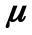
Margin of Error - 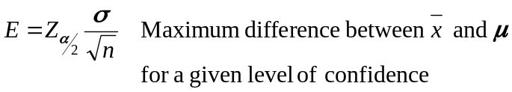

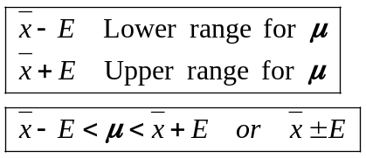

Steps:
- check requirements.
- Find critical value. 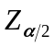 for a given confidence level
- Find the margin of Error 
- Find confidence interval 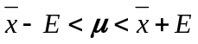

Example:
Random sample of 40 students. The average resting heart-rate for the sample was 76.3 beats per minute.
Assume the Population Standard Deviation is 12.5 beats per minute.
Construct a 99% confidence interval for the average resting heart-rate for the rest of the population.
- Requirements check
- Random Sample There is a random sample
- Population Standard Deviation 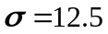
- Sample size >30
- Find critical value.
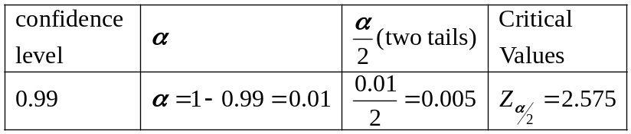
- Find Margin of Error
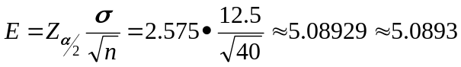
- Find confidence Interval
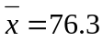
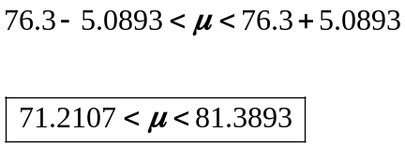

99% sure the average resting heart-rate of the population is between 71.2107 and 81.38.93 beats per minute.

Finding the required sample size for a given margin of error:

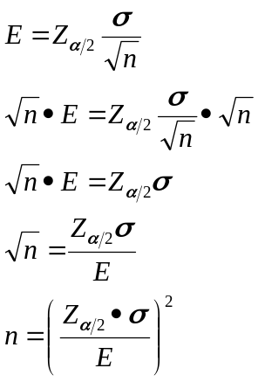

Example
We want to construct a 95% confidence interval for the mean of IQ scores.
Assume population standard deviation to be 15,
We want the sample mean to be within two points of population mean.
How big does that sample need to be?
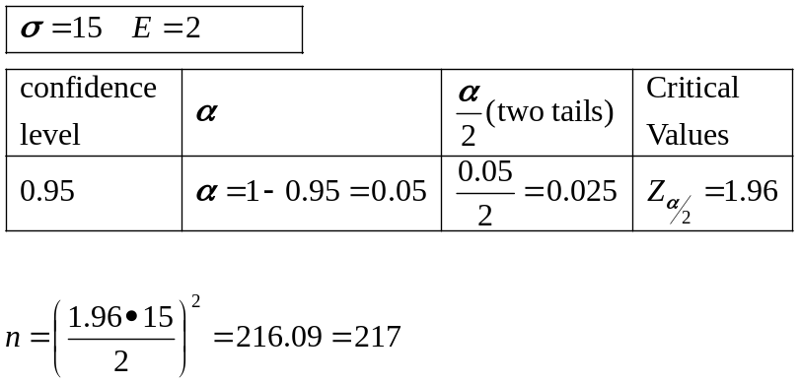

The sample size must be at least 217

